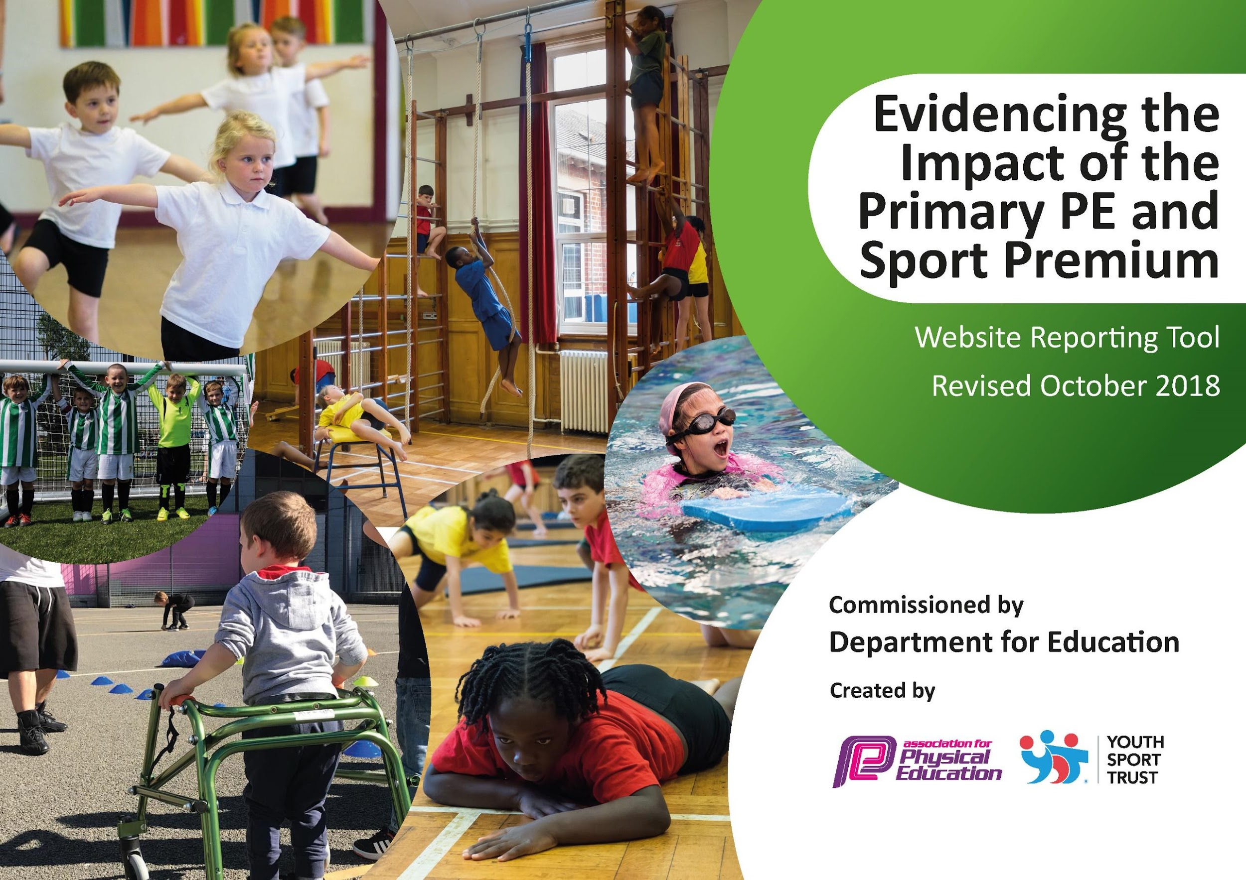
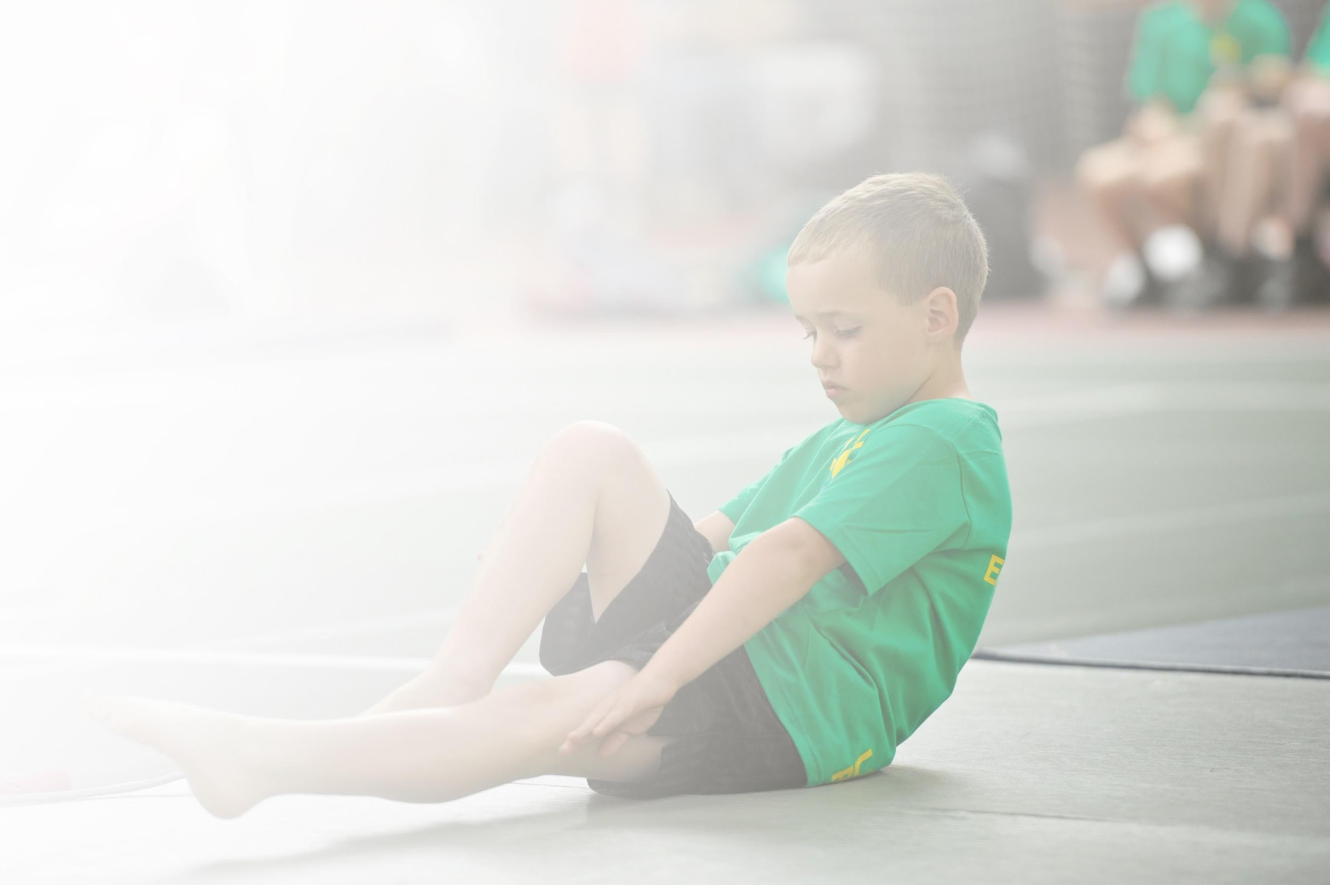
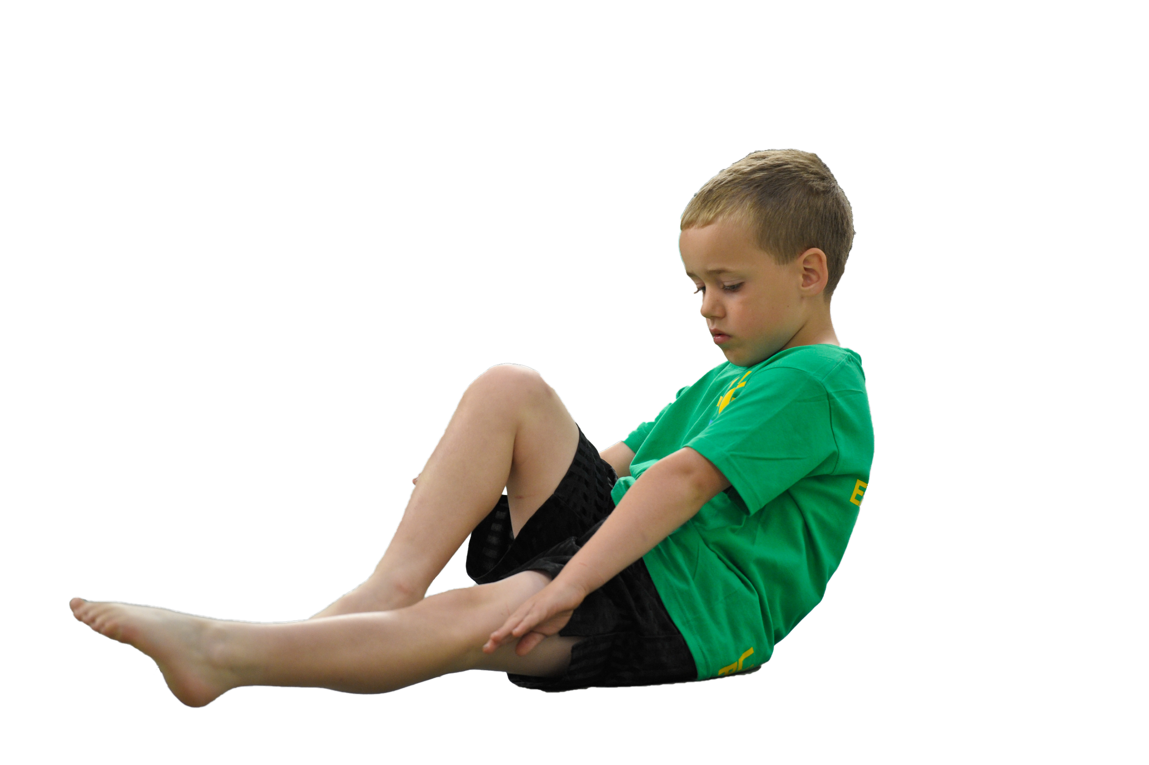
Schools must use the funding to make additional and sustainable improvements to the quality of Physical Education, Sport and Physical Activity (PESPA) they offer. This means that you should use the Primary PE and Sport Premium to:

- Develop or add to the PESPA activities that your school already offer
- Build capacity and capability within the school to ensure that improvements made now will benefit pupils joining the school in future years

Please visit gov.uk for the revised DfE guidance including the 5 key indicators across which schools should demonstrate an improvement. This document will help you to review your provision and to report
your spend. DfE encourages schools to use this template as an effective way of meeting the reporting requirements of the Primary PE and Sport Premium.

We recommend you start by reflecting on the impact of current provision and reviewing the previous
spend. Under the Ofsted Schools Inspection Framework, inspectors will assess how effectively leaders use the Primary PE and Sport Premium and measure its impact on outcomes for pupils, and how effectively governors hold them to account for this.

Schools are required to publish details of how they spend this funding as well as on the impact it has on pupils’ PE and sport participation and attainment by the end of the summer term or by 31 July 2021 at the
latest.
We recommend regularly updating the table and publishing it
on your website throughout the year, as evidence of your
ongoing review into how you are using the money to
secure maximum, sustainable impact. To see an
example of how to complete the table please
click HERE.

Support for review and reflection - considering the 5 key indicators from DfE, what development needs are a priority for your setting and your students now and why? Use the space below to reflect on previous spend, identify current need and priorities for the future.

Key achievements to date: | Areas for further improvement and baseline evidence of need:
- Improvement in general fitness and gross motor skills in all pupils due to increased active learning.  - high quality PE lessons taught through specialist sports coaches and CPD for teachers | - Continued investment in resources for the teaching of P.E. Maintain a good level of high quality equipment whilst broadening the resources so we can offer a wider range of sports  - Continued investment in resources for playtime activities and Active Learning.  - Continued staff training and awareness of high quality P.E teaching  - Continued staff training in facilitating active learning and purchase of further resources to support this  - Build further on links with local sports clubs and coaches to encourage high take up of sports out of school hours  - Further use Sports Premium to enhance children’s mental health and wellbeing through active learning, outdoor activities and yoga  - Improved EYFS resources such as ‘Healthy movers’ program  - Develop children’s social skills post covid by working with older people from the community,

Meeting national curriculum requirements for swimming and water safety | Please complete all of the below:
What percentage of your current Year 6 cohort swim competently, confidently and proficiently over a distance of at least 25 metres?  N.B. Even though your children may swim in another year please report on their attainment on leaving  primary school. | n/a
What percentage of your current Year 6 cohort use a range of strokes effectively [for example, front crawl, backstroke and breaststroke]? | % n/a
What percentage of your current Year 6 cohort perform safe self-rescue in different water-based situations? | % n/a
Schools can choose to use the Primary PE and Sport Premium to provide additional provision for swimming but this must be for activity over and above the national curriculum requirements. Have you used it in this way? | Yes/No

Action Plan and Budget Tracking
Capture your intended annual spend against the 5 key indicators. Clarify the success criteria and evidence of impact that you intend to measure to evaluate for students today and for the future.
From September 2020 the school will have to follow Government guidelines. This may mean that we have less clubs and extra-curricular activities than normal, at least in the short term. The ability to teach the full range of P.E and provide equipment for active playtimes will be impacted. The school is committed to active healthy pupils as we appreciate that the best way to fight the virus is to promote healthy active lifestyles but we will put pupil and staff safety first.

Academic Year: 2022/23 | Total fund allocated: £16, 445.00 | Date Updated:16/011/22
Key indicator 1: The engagement of all pupils in regular physical activity – Chief Medical Officer guidelines recommend that primary school children undertake at least 30 minutes of physical activity a day in school |  |  |  | Percentage of total allocation:
 |  |  |  | 12 %
School focus with clarity on intended impact on pupils: | Actions to achieve: | Funding allocated: | Evidence and impact: | Sustainability and suggested next steps:
Access to loose parts play equipment during play times throughout the whole school year in order to develop core strength and teamwork.  Develop social and emotional skills for the children who need further input, through Active all ages  Early years participate in Healthy Movers program to promote physical development | Purchase a storage shelter for play equipment.  Replace shelving unit in shed  Purchase outdoor play equipment - loose parts  Hold an Active all ages club/session, Buy curling equipment  Buy Healthy Movers pack  AC to teach Healthy Movers program twice a week. (This can be incorporated into active maths/English) | £1000  £500  £72 | New shelving and storage shelter will be purchased.  Long term play equipment purchased for year round use.  New storage solutions provide easy access to resources, enabling constant use all year round.  Curling equipment will be purchased.  ZT running Active all ages in Spring term.  Healthy Movers Program is taught twice a week to early years. | Resources available long term for all children beyond premium funding  Beyond funding, Active all ages sessions/club to be held and curling resources remain available.  Healthy Movers resources remain available and used with early years on a regular basis.
Key indicator 2: The profile of PESSPA being raised across the school as a tool for whole school improvement |  |  |  | Percentage of total allocation:
 |  |  |  | 35%
School focus with clarity on intended impact on pupils: | Actions to achieve: | Funding allocated: | Evidence and impact: | Sustainability and suggested next steps:
Maintain high priority of the development of pupils’ basic skills in number and times table knowledge and application through Active Learning  Improve mental wellbeing and physical fitness through Active Learning opportunities and CPD | ZT to teach years 3 + 4 Active times tables activities once a week for half a term each term. ZT to teach Active Maths or English to all classes one half term in every term.  Teachers to teach active lessons across the whole curriculum through ZT support and CPD  ZT to display active breaks cards on hall PE display  Purchase resources to support this  Have new markings painted on playground  ZT use Enrich Orienteering resources in CPD to encourage teachers to use them.  Yoga Bairns lessons for 11 weeks for years R-4  Teachers to use Yoga resources  Team Challenge sessions x 6 Spring term 2 taught by ZT  Pupil voice questionnaires to be completed by all children to monitor mental health and well being. | £4050  £375.41  £700  £750 | Children learn and apply basic number skills and times tables facts within maths lessons, using active learning as a tool to recall facts.  Children participate in Active lessons with improved fitness and increased positive attitudes.  Pupil surveys to assess above perceptions by pupils and teachers  Teachers have increased motivation to participate in physical activities with children, modelling positive attitudes towards sport.  Team challenge shows increased communication skills and social development.  Yogi Bairns develops self regulation  Pupil voice shows positive view of Yoga and Team challenge. | All teachers are upskilled in active learning to continue teaching active lessons throughout the curriculum.  Enrich Orienteering resources are available for use long term.  Teachers are confident to use yoga resources with pupils when necessary and on a regular basis to maintain mental wellbeing.

Key indicator 3: Increased confidence, knowledge and skills of all staff in teaching PE and sport |  |  |  | Percentage of total allocation:
 |  |  |  | 21%
School focus with clarity on intended  impact on pupils: | Actions to achieve: | Funding  allocated: | Evidence and impact: | Sustainability and suggested  next steps:
Improve the quality of teaching and learning in PE | ZT to teach High Quality PE lessons as CPD for teachers, sharing developments in Get Set 4 PE planning and assessment.  Continue with subscription to GetSet4PE  Specialist PE teachers to teach ball skills, net and wall games, gymnastics and striking and fielding as CPD for staff. | £3150 | Get Set 4 PE planning is shared with all staff and the assessment tool.  Assessment and progression of all children in PE is evident.  Pupils display high quality PE skills  Teachers’ knowledge of the PE curriculum is increased and confidence to teach PE independently. | Continue to use Get Set 4 PE subscription beyond funding  All teaching staff have knowledge, understanding and confidence to teach high quality PE lessons.
Key indicator 4: Broader experience of a range of sports and activities offered to all pupils |  |  |  | Percentage of total allocation:
 |  |  |  | 28%
School focus with clarity on intended  impact on pupils: | Actions to achieve: | Funding  allocated: | Evidence and impact: | Sustainability and suggested  next steps:
Provide opportunities to learn new skills and sports.  Provide coaches to teach specific sports skills. | Workshops for new sports/activities, including skipping, skateboarding, curling, team challenge and dance.  Employ Mrs Bridgewater to teach gymnastics , athletics and tennis lessons and clubs.  Autumn Term 1 + 2  Employ Dougie Hall to teach Rugby/ball skills lessons and club  Spring Term 2  Steve Nutt to teach Cricket to all classes  Summer Term 1  ZT to provide sports clubs throughout the year including; playground and ball games, running, team challenge, golf, OAA | £123  £1050  £630  £660  £1332 | Curling, skateboarding, and skipping workshops take place.  Pupils are motivated and enthusiastic to participate in new sports. Self confidence, self belief and fitness are all improved.  Pupil voice shows positive attitudes to trying new sports.  Gym, tennis, Yoga, cricket and rugby lessons and clubs take place.  Registers taken for each club to record participation  A club takes place once a week provided by ZT.  A different sport each half term.  Registers taken to record participation | Curling resources are available to use beyond funding.  Sports clubs are continued beyond funding, paid by parents
Key indicator 5: Increased participation in competitive sport |  |  |  | Percentage of total allocation:
 |  |  |  | 2%
School focus with clarity on intended  impact on pupils: | Actions to achieve: | Funding  allocated: | Evidence and impact: | Sustainability and suggested  next steps:
Participate in a broader range of sports competitions between partnership schools  Encourage participation in local sports clubs where competition takes place | Provide transport to Competitions including School Games.  Provide PE specialist teacher to support with events (ZT)  Promotion of local sports clubs through partnership and school games events and sports workshops. | £220  £700 | Participation of all children in KS1 and KS2 in at least one sports event throughout the year.  Year 4 Girls Football 9th March  Longridge Cross Country 16th March  Year 4 transition - orienteering  Skipping festival 18th July  Register kept of participation in events  Register kept of participation in local sports clubs out of school  Promote local sports clubs through Seesaw and PE display in Hall | Promotion of local sports clubs is continued through Seesaw and school displays.
Total £16445

- Enhanced P.E equipment stock providing high quality equipment across an increasing range of sports to facilitate more participation within P.E sessions
- High uptake of clubs in the local community by children in our school due to promotion of local clubs especially cricket where a high number of children attend Tillside cricket club and rugby at Berwick Rugby Club.
- Consistent take up of after school clubs subsidised by the school
- Range of after school sports offered is wide and varied to appeal to all and to allow children to experience sports and activities that they would not normally
- No child misses out on after school sports provision because of cost
- Specialist coaching for groups across the whole school
- Use Sports Premium to enhance children’s mental health and wellbeing through after school clubs, Active lessons including Maths, English, PSHE and Yoga

